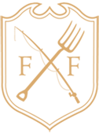

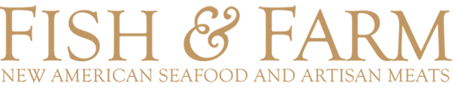

HAPPY HOUR
Daily from 3 – 8 PM

FISH AND CHIPS 10
Line Caught Cod, House Made Tartar Sauce.

MUSSELS 10

Choice of Preparation
Mariniere
Garlic, Parsley, White Wine
Basquaise
roasted bell pepper, parsley, white wine, Spanish chorizo

CHEESE PIZZA 9

MUSHROOM PIZZA 10

FRIES 3

Cherry Ketchup

SWEET POTATO FRIES 4

$5 SELECTED

$1 OFF DRAFT BEERS

$5 SELECTED WINES

$5 HOUSE WELL DRINKS

Draft Beer
Wine
House Cocktail

DRAFT BEER

Anchor Steam, San Francisco, CA, 4.9% ABV 7
Blue Moon, Golden, CO, 5.4% ABV 6
Boont Amber Ale, Boonville, CA, 5.8% ABV 7
Coors Light, Golden, CO, 4.2% ABV 5
Crispin Hard Cider, Colfax, CA, 5% ABV 7
Firestone 805, Paso Robles, CA, 4.7 % ABV 7
Green Flash Soul Style IPA, San Diego, CA, 6.8% ABV 7
Guiness Draught, Dublin, Ireland, 4.2% ABV 7
Heineken Lager, Zoeterwoude, Netherlands, 5% ABV 7
Lagunitas IPA, Petaluma, CA, 6.2% ABV 7
Pilsner Urquell, Plzen, Czech Republic, 4.4% ABV 7
Shiner White Wing Witbier, Shiner, TX, 4.7 % ABV 7
Sierra Nevada Pale Ale, Chico, CA, 5.6 % ABV 7

- - - Please inquire about our seasonal beers on tap - - -

BOTTLED BEER

Calicraft Buzzerkeley Sparkling Ale, Walnut Creek, CA, 7% ABV 7
Corona Extra Pale Lager, Mexico City, Mexico, 4.6% ABV 7
Deschutes Black Butte Porter, Bend, OR, 5.2% ABV 7
Einstok Icelandic Pale Ale, Akureyri, Iceland, 5.6% 7
He’Brew Messiah Nut Brown Ale, Clifton Park, NY, 5.2% ABV 7
Lagunitas Little Sumpin’ Sumpin’ Ale, Petaluma, CA, 7.5% ABV 7
Modelo Especial, Mexico City, Mexico, 4.4% ABV 7
Not Your Father’s Root Beer, Wauconda, IL, 5.9% ABV 7
Schmaltz Slingshot Lager, Clifton Park, NY, 5.5% ABV 7
Stella Artois, Leuven, Belgium, 5% ABV 7

CANNED BEER & CIDER

Anchor Lager, San Francisco, CA, 4.9% ABV 5.5
Golden Road “Get Up Offa That Brown”, Los Angeles, CA, 5.5% ABV 6
Rekorderlig Pear Cider, Sweden, 4.5% ABV 6.5
Rekorderlig Strawberry Lime Cider, Sweden, 4.5% ABV 6.5

