DRAFT BEER

Magner’s Cider, Ireland $7

Pale Lager, Peroni, Rome, 4.7% ABV $6

Orange Ave Wit, Coronado, San Diego,
5.72% ABV $7

Pilsner Urquell,
Czech Republic, 4.4% ABV $7

Weihenstephan, Original Lager $8

Anchor Steam $7
San Francisco, 4.9% ABV

“Mermaid” Red Ale, Coronado, San Diego, $8
5.7% ABV

Hop Valley Pale Ale, $7
Oregon, 6.5% ABV

IPA, Lagunitas Brewing, $7
Petaluma, CA, 6.2% ABV

Anchor “Go West” IPA, $7
San Francisco, 6.7% ABV

Guinness Draught, Dublin, 4.2% ABV $7

**ASK ABOUT OUR 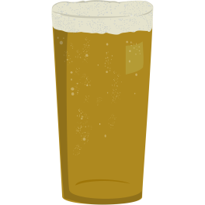
ROTATING SELECTION OF
SEASONAL DRAFT BEERS

BOTTLES/CANS

Rekorderlig Pear $6

Rekorderlig Strawberry Lime $6

Michelob Ultra-Light $4

Miller High Life $4

Miller Light $5

Amstel Light $6

Corona Extra Pale Lager $5

“Slingshot” American Lager, Shmaltz $5

Orval Trappist Ale $8

Einstok Icelandic Pale Ale $6

Einstok Icelandic White Ale $6

Einstok Icelandic Toasted Porter $6

Murphy’s Irish Stout $5

TRY A
LIMITED RELEASE
CORONADO
“STUPID” BARREL AGED STOUT
10% ABV
22 ounce Bottle: $20

